**UNIT-III**

**Questions**

1. A. Write a short note on rnorm() with examples.

**ANSWER:**

* To draw random numbers from the normal distribution use the rnorm function, which optionally allows the specification of the mean and standard deviation.

>#10 draws from the standard 0-1 normal distribution

>rnorm(n=10)

[1]0.3746584 0.7368645 0.2408023 -0.1220292 0.6525665

[6]0.3313728 0.5401996 1.6598050 -0.7777772 0.4904597

>#10 draws from the 100-20 distribution

>rnorm(n=10, mean=100, sd=20)

[1] 94.99245 125.31772 120.70047 118.07148 111.88081 99.32752

[7] 92.36758 87.94429 115.18968 91.88554

----------------------------------------------------------------------------------------------------------------

B. With examples explain briefly about dnorm().

**ANSWER:**

* The density for the normal distribution is calculated using dnorm.

>randNorm10<-rnorm(10)

randNorm10

[1] 1.8081780 0.7159731 0.4119520 -0.1659213 -0.1597631

[6] 1.0941883 0.1981299 -1.3998152 -2.2787374 -0.3403679

**>dnorm(randNorm10)**

[1] 0.07779389 0.30874263 0.36648754 0.39348848 0.39388328

[6] 0.21924564 0.39118830 0.14976620 0.02974005 0.37649004

**>dnorm(c(-1,0,1))**

[1] 0.2419707 0.3989423 0.2419707

* dnorm returns the probability of a specific number occurring. While it is technically mathematically impossible to find the exact probability of a number from a continuous distribution, this is an estimate of the probability. Like with rnorm, a mean and standard deviation can be specified for dnorm.

---------------------------------------------------------------------------------------------------------------------

C. Write the code to plot “random normal variables and their densities”, which results in a bell curve.

**ANSWER:**

**R-Code:**

ggplot(data.frame(x=randNorm, y=randDensity)) + aes(x=x,y=y) + geom_point() + labs(x=“Random Normal Variables”, y= “Density”)

**Output:**

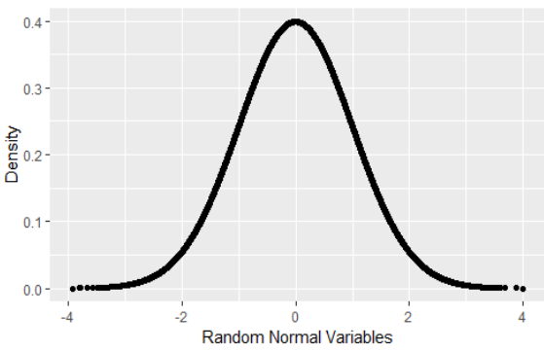

-------------------------------------------------------------------------------------------------------------------

2.A. Write a short note on Normal Distribution.

**ANSWER:**

* The most famous, and most used, statistical distribution is the normal distribution, sometimes referred to as the Gaussian distribution, which is defined as

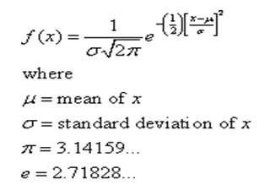

**Rnorm():**

* To draw random numbers from the normal distribution use the rnorm function, which optionally allows the specification of the mean and standard deviation.

>#10 draws from the standard 0-1 normal distribution

>rnorm(n=10)

[1]0.3746584 0.7368645 0.2408023 -0.1220292 0.6525665

[6]0.3313728 0.5401996 1.6598050 -0.7777772 0.4904597

>#10 draws from the 100-20 distribution

>rnorm(n=10, mean=100, sd=20)

[1] 94.99245 125.31772 120.70047 118.07148 111.88081 99.32752

[7] 92.36758 87.94429 115.18968 91.88554

**Dnorm():**

* The density for the normal distribution is calculated using dnorm.

>randNorm10<-rnorm(10)

randNorm10

[1] 1.8081780 0.7159731 0.4119520 -0.1659213 -0.1597631

[6] 1.0941883 0.1981299 -1.3998152 -2.2787374 -0.3403679

**>dnorm(randNorm10)**

[1] 0.07779389 0.30874263 0.36648754 0.39348848 0.39388328

[6] 0.21924564 0.39118830 0.14976620 0.02974005 0.37649004

**>dnorm(c(-1,0,1))**

[1] 0.2419707 0.3989423 0.2419707

* dnorm returns the probability of a specific number occurring. While it is technically mathematically impossible to find the exact probability of a number from a continuous distribution, this is an estimate of the probability. Like with rnorm, a mean and standard deviation can be specified for dnorm.

**Pnorm():**

>pnorm(randNorm10)

[1]0.96471060 0.76299601 0.65981269 0.43410943 0.43653383 0.86306380

[7]0.57852828 0.08078433 0.01134134 0.36678975

>pnorm(c(-3,0,3))

[1] 0.001349898 0.500000000 0.998650102

>pnorm(-1)

[1] 0.1586553

* By default this is left-tailed. To find the probability that the variable falls between two points, we must calculate the two probabilities and subtract them from each other.

>pnorm(1) – pnorm(0)

[1] 0.3413447

>pnorm(1)-pnorm(-1)

[1] 0.6826895

---------------------------------------------------------------------------------------------------------------------

B. With examples explain in detail about Binomial distribution.

**ANSWER:**

* Like the normal distribution, the binomial distribution is well represented in R. Its probability mass function is

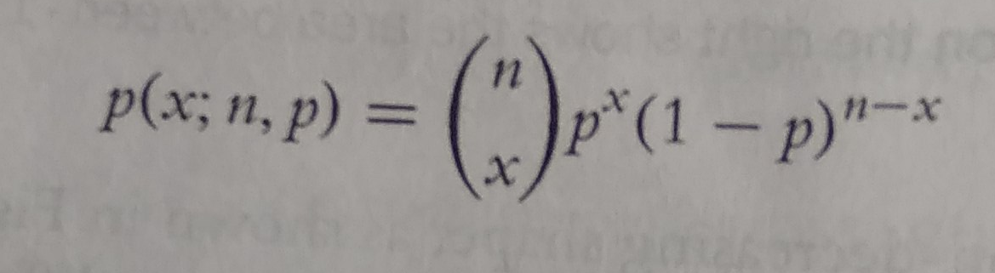

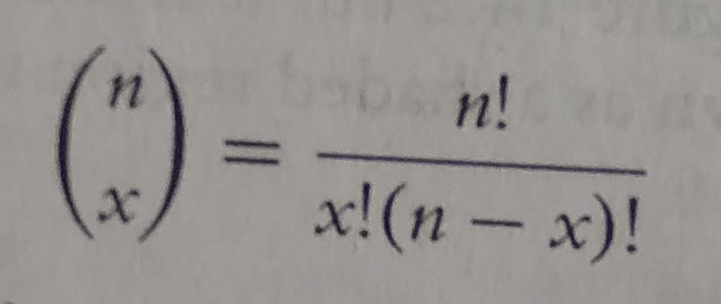

and n is the number of trails and p is the probability of success of a trail.

* The mean is np and the variance is np(1-p). When n=1 this reduces to the bernoulli distribution.
* Generating random numbers from the binomial distribution is not simply generating random numbers but rather generating the number of successes of independent trails.
* To simulate the number of successes out of ten trails with probability 0.4 of success, we run rbinom with n=1 (only one run of the trails), size=10 (trail size of 10), and prob=0.4 (probability of success is 0.4).

**Rbinom():**

>rbinom(n=1,size=10,prob=0.4)

[1] 6

> binomData<-data.frame(Successes=rbinom(n=10000,size=10,prob=0.3))

>ggplot(binomData, aes(x=Successes)) + geom_histogram(binwidth=1)

**Output:**

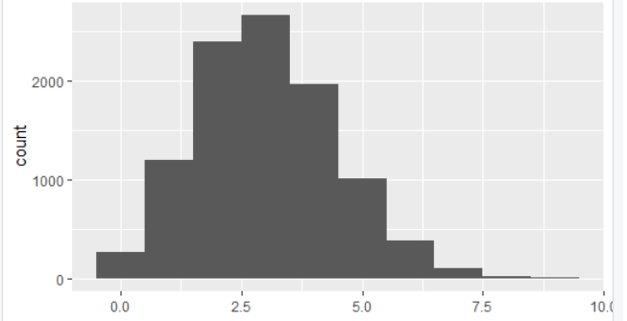

**Dbinom():**

>dbinom(x=3, size=10, prob=0.3)

[1] 0.2668279

**Pbinom():**

>#probability of 3 or fewer successes out of 10

>pbinom(q=3, size=10, prob=0.3)

[1] 0.6496107

**Qbinom():**

* Given a certain probability, qbinom returns the quantile, which for this distribution is the number of successes.

>qbinom(p=0.3,size=10,prob=0.3)

[1] 2

>qbinom(p=c(0.3,0.35,0.4,0.5,0.6), size=10,prob=0.3)

[1] 2 2 3 3 3

---------------------------------------------------------------------------------------------------------------------

1. A. With examples write a short note on rbinorm()

**ANSWER:**

* To simulate the number of successes out of ten trails with probability 0.4 of success, we run rbinom with n=1 (only one run of the trails), size=10 (trail size of 10), and prob=0.4 (probability of success is 0.4).

>rbinom(n=1,size=10,prob=0.4)

[1] 6

* That is to say that ten trails were conducted, each with 0.4 probability of success, and the number generated is the number that succeeded. As this is random, different numbers will be generated each time.

----------------------------------------------------------------------------------------------------------------

B. With examples write a short note on pbinorm() and qbinorm().

**ANSWER:**

**Pbinom():**

>#probability of 3 or fewer successes out of 10

>pbinom(q=3, size=10, prob=0.3)

[1] 0.6496107

**Qbinom():**

* Given a certain probability, qbinom returns the quantile, which for this distribution is the number of successes.

>qbinom(p=0.3,size=10,prob=0.3)

[1] 2

>qbinom(p=c(0.3,0.35,0.4,0.5,0.6), size=10,prob=0.3)

[1] 2 2 3 3 3

**---------------------------------------------------------------------------------------------------------------------**C. Write a short note on Poisson distribution.

**ANSWER:**

* Another popular distribution is the Poisson Distribution, which is for count data. Its probability mass function is

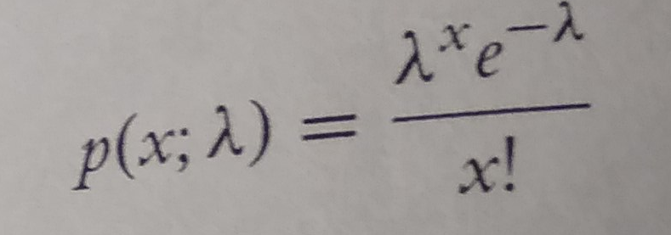

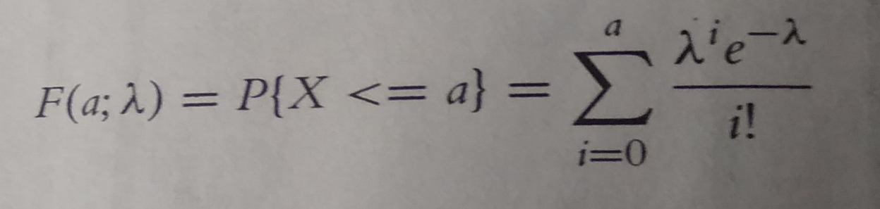

Where λ is both the mean and variance.

* To generate random counts, the density, the distribution and quantiles use rpois, dpois, ppois and qpois, respectively.
* As λ grows large the poisson distribution begins to resemble the normal distribution. To see this we will simulate 10,000 draws from the Poisson distribution and plot their histograms to see the shape.

>#generate 10,000 random counts from 5 different Poisson distributions

>pois1<-rpois(n=10000, lambda=1)

>pois2<-rpois(n=10000, lambda=2)

>pois5<-rpois(n=10000, lambda=5)

>pois10<-rpois(n=10000,lambda=10)

>pois20<-rpois(n=10000,lambda=20)

>pois<-data.frame(Lambda.1=pois1, Lambda.2=pois2, Lambda.5=pois5, Lambda.10=pois10, Lambda.20=pois20)

----------------------------------------------------------------------------------------------------------------

1. A. Write a short note on summary() with examples.

**ANSWER:**

* The first thing many people think of in relation to statistics is the average, or mean, as it is properly called.

>x<-sample(x=1:100, size=100, replace= TRUE)

>x

[1] 81 100 79 66 32 87 85 10 46 76 71 25 100 51

[15] 17 60 15 6 60 89 23 100 64 28 74 12 12 10

[29] 48 79 10 87 50 21 96 85 40 41 64 18 92 70

[43] 44 28 73 22 35 93 18 64 43 50 53 52 84 99

[57] 25 61 41 47 1 66 93 22 77 56 17 74 19 85

[71] 25 11 27 83 100 37 53 64 60 55 69 58 62 53

[85] 62 36 96 68 11 54 45 69 35 63 38 16 95 1

[99] 80 69

**mean(x)**

[1] 53.17

* This is the simple arithmetic mean

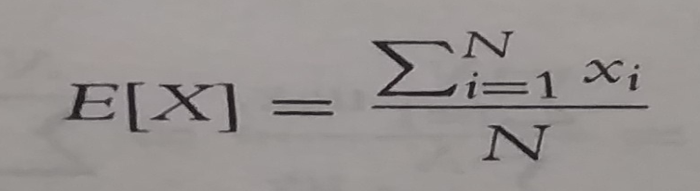

mean(y,na.rm=TRUE)

[1] 51.025

**Weighted Mean**

weighted.mean(x=grades,w=weights)

[1] 84.625

* The formula for weighted.mean is given by

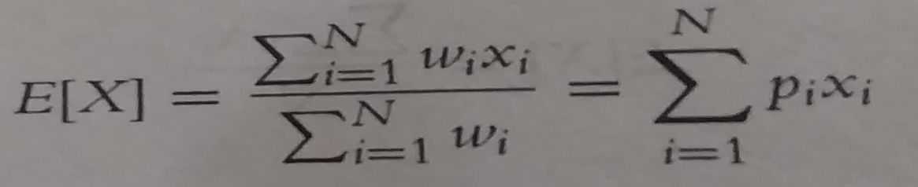

**Variance:**

var(x)

[1] 710.0469

* This calculates variance as

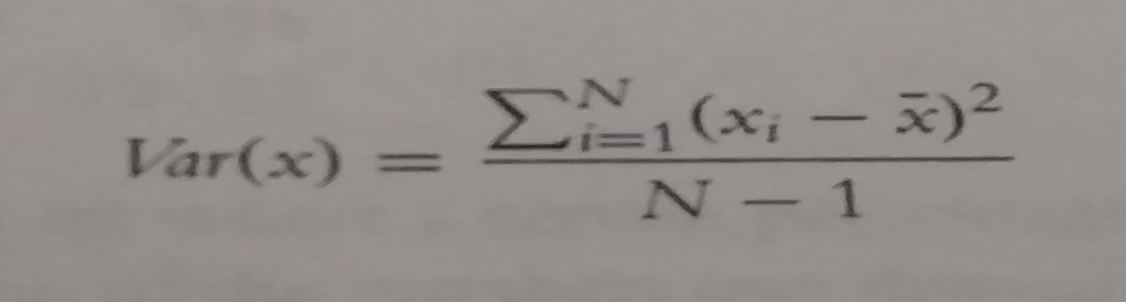

**Standard Deviation:**

sd(x)

[1] 26.6467

>sd(y,na.rm= TRUE) #if u want to discard NA values and then calculate

[1] 27.4761

* Other commonly used functions summary statistics are **min, max and median**. Of course all of these also have na.rm arguments.

>min(x)

[1] 3

>max(x)

[1] 99

>median(x)

[1] 43

>min(y)

[1] NA #because y may contain NA values

**Summary:**

>summary(x)

Min 1st Qu. Median Mean 3rd Qu. Max

1.00 17.75 43.00 44.51 68.25 100.00

>summary(y)

Min 1st Qu. Median Mean 3rd Qu. Max NA’s

2.00 18.00 40.50 43.59 67.00 100.00 20

------------------------------------------------------------------------------------------------------------------

B. What is the difference between mean() and weighted.mean().

**ANSWER:**

**mean(x)**

[1] 53.17

* This is the simple arithmetic mean



mean(y,na.rm=TRUE)

[1] 51.025

**Weighted Mean**

weighted.mean(x=grades,w=weights)

[1] 84.625

* The formula for weighted.mean is given by



---------------------------------------------------------------------------------------------------------------------

C. With examples explain in detail about quantile().

**ANSWER:**

>#calculate the 25th and 75th quantile

>quantile(x,probs=c(0.25,0.75))

25% 75%

17.75 68.25

>#try the same on y

>quantile(y, probs=c(0.25,0.75))

Error: missing values and NaN’s not allowed if ‘na.rm’ is FALSE

>#this time use na.rm=TRUE

>quantile(y, probs=c(0.25,0.75),na.rm=TRUE)

25% 75%

18 67

>#compute other quantiles

Quantile(x, probs=c(0.1,0.25,0.5,0.75,0.99))

10% 25% 50% 75% 100%

6.00 12.75 43.00 68.25 98.02

**Note:** Quantiles are numbers in a set where a certain percentage of the numbers are smaller than the quantile. For instance, of the numbers one through 200, the 75th quintile the number that is larger than 75% of the numbers is 150.25

---------------------------------------------------------------------------------------------------------------------

5.A. Write a short note on correlation and covariance.

**ANSWER:**

**Correlation and Covariance:**

**Covariance**

* Covariance signifies the direction of the linear relationship between the two variables. By direction we mean if the variables are directly proportional or inversely proportional to each other. (Increasing the value of one variable might have a positive or a negative impact on the value of the other variable).
* The values of covariance can be any number **between the two opposite infinities**. Also, it’s important to mention that covariance only measures how two variables change together, not the dependency of one variable on another one.
* The value of covariance between 2 variables is achieved by taking the summation of the product of the differences from the means of the variables as follows:
* The upper and lower limits for the covariance depend on the variances of the variables involved. These variances, in turn, can vary with the scaling of the variables. Even a change in the units of measurement can change the covariance.
* Thus, covariance is only useful to find the direction of the relationship between two variables and not the magnitude. Below are the plots which help us understand how the covariance between two variables would look in different directions.

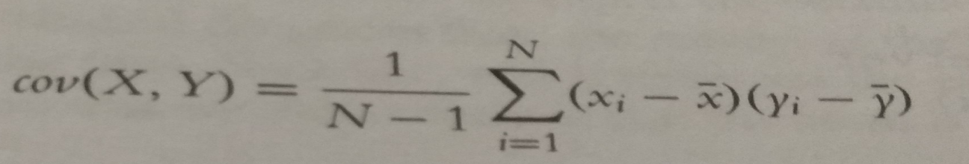

**Examples:**

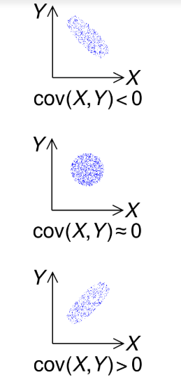

**R -Code:**

cov(economics$pce,economics$psavert)

[1] -9361.028

**Correlation:**

* Correlation analysis is a method of statistical evaluation used to study the strength of a relationship between two, numerically measured, continuous variables.
* It not only shows the kind of relation (in terms of direction) but also how strong the relationship is. Thus, we can say the correlation values have standardized notions, whereas the covariance values are not standardized and cannot be used to compare how strong or weak the relationship is because the magnitude has no direct significance**. It can assume values from -1 to +1.**
* To determine whether the covariance of the two variables is large or small, we need to assess it relative to the standard deviations of the two variables.

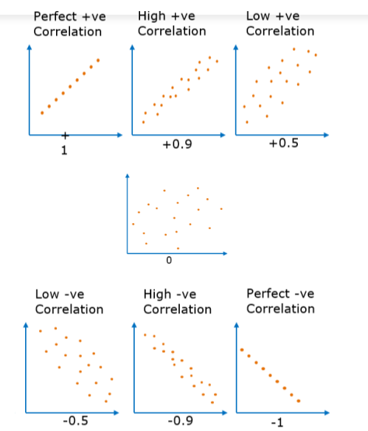

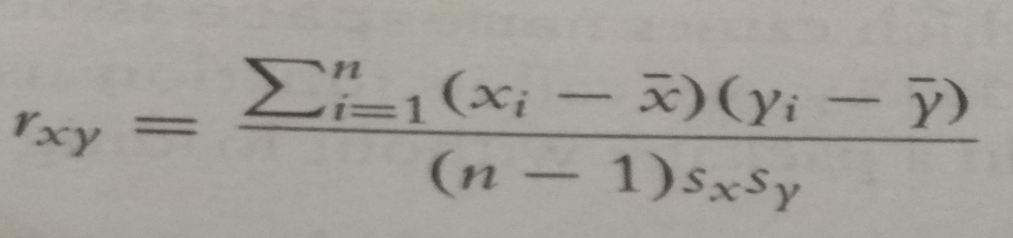

**R-code:**

cor(economics$pcs,economics$psavert)

[1] -0.9271222

**Difference between correlation and covariance**:

|  |  |
| --- | --- |
| **Covariance** | **Correlation** |
| Covariance is a measure to indicate the extent to which two random variables change in tandem. | Correlation is a measure used to represent how strongly two random variables are related to each other. |
| Covariance is nothing but a measure of correlation. | Correlation refers to the scaled form of covariance. |
| Covariance indicates the direction of the linear relationship between variables. | Correlation on the other hand measures both the strength and direction of the linear relationship between two variables. |
| Covariance can vary between -∞ and +∞ | Correlation ranges between -1 and +1 |
| Covariance is affected by the change in scale. If all the values of one variable are multiplied by a constant and all the values of another variable are multiplied, by a similar or different constant, then the covariance is changed. | Correlation is not influenced by the change in scale. |
| Covariance assumes the units from the product of the units of the two variables. | Correlation is dimensionless, i.e. It’s a unit-free measure of the relationship between variables. |
| Covariance of two dependent variables measures how much in real quantity (i.e. cm, kg, liters) on average they co-vary. | Correlation of two dependent variables measures the proportion of how much on average these variables vary w.r.t one another. |
| Covariance is zero in case of independent variables (if one variable moves and the other doesn’t) because then the variables do not necessarily move together. | Independent movements do not contribute to the total correlation. Therefore, completely independent variables have a zero correlation. |

B. Write a short note on t-tests.

**ANSWER:**

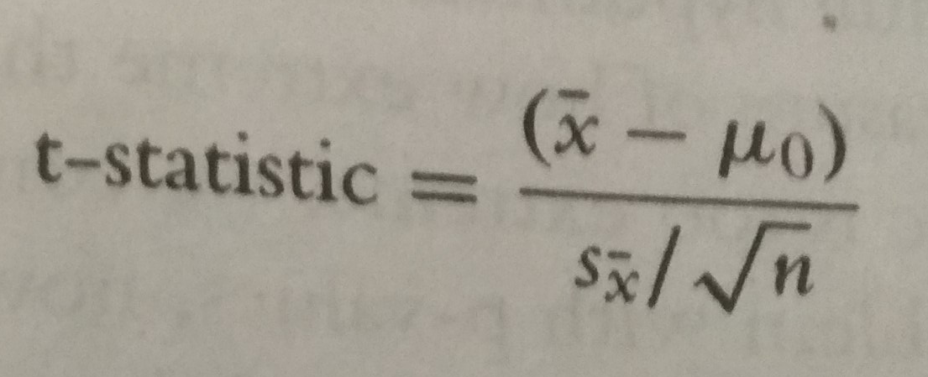

**One Sample T-test:**

**R-code:**

t.test(tips$tip,alternative=“two.sided”, mu=2.5)

**Two-sample T-Test:**

**R-Code:**

t.test(tip~sex, data=tips, var.equal=TRUE)

**Paired sample two-test:**

**R-code:**

t.test(father.son$fheight, father.son$sheight, paired=TRUE)

**T-test used for**

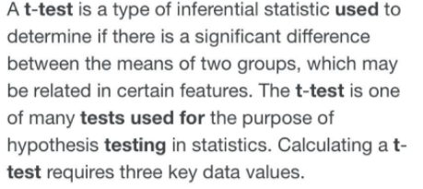

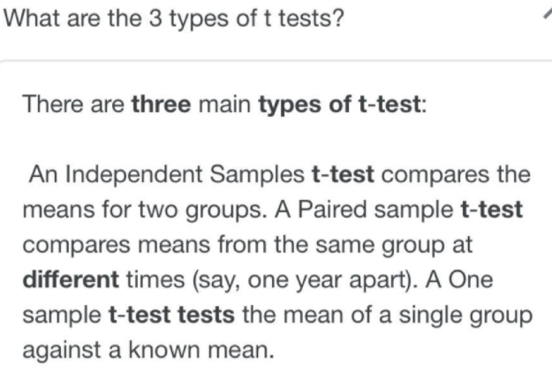

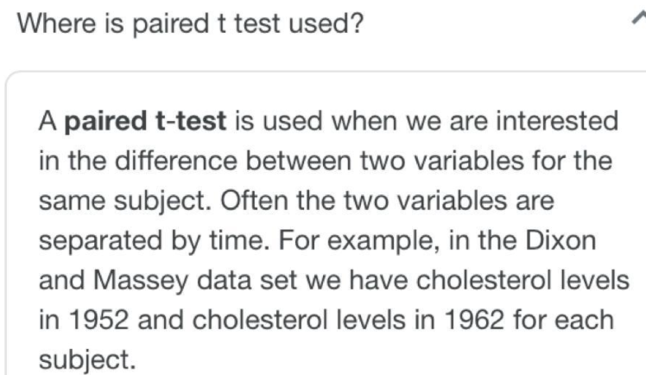

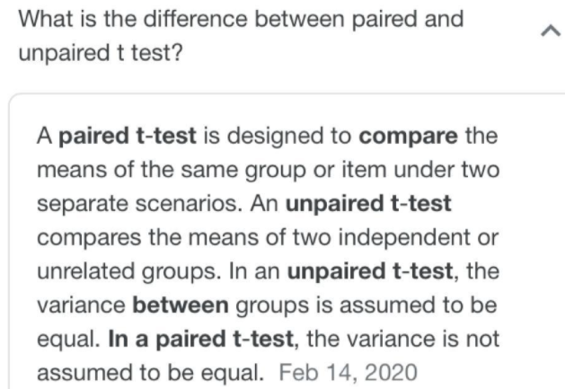

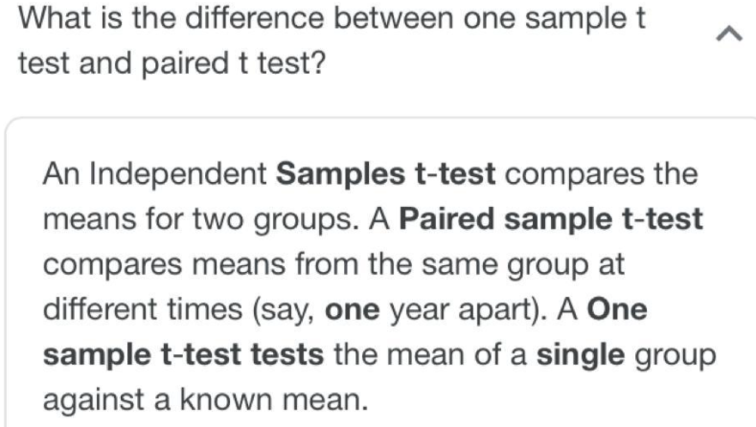

6.Write a short note on ANOVA.

**ANSWER:**

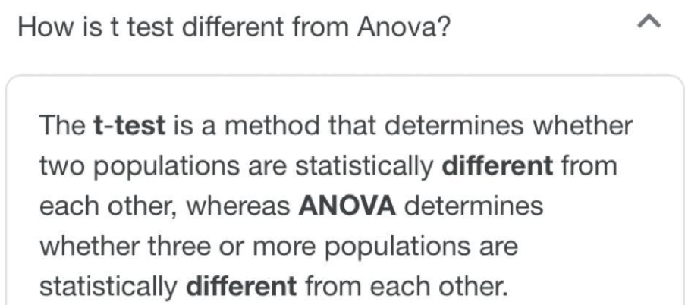

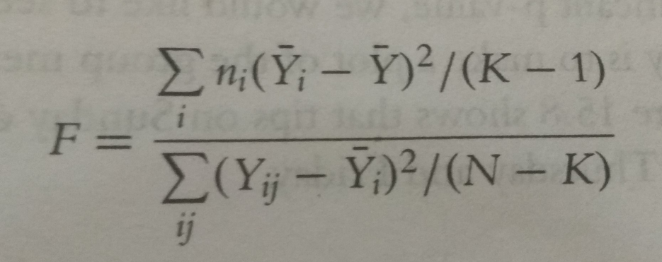

**R-Code:**

>tipAnova<-aov(tip~day-1,tips)

>tipIntercept<-aov(tip~day,tips)

>tipAnova$coefficients

7. Problems related to distributions.

**Solutions:**

**Eg1:**

If there are twelve cars crossing a bridge per minute on average, find the probability of having seventeen or more cars crossing the bridge in a particular minute?

**Poisons Distribution:**

λ= 12

P(x>=17)

=1-p(x<17)

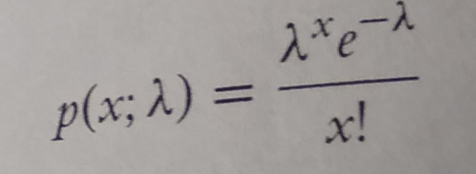

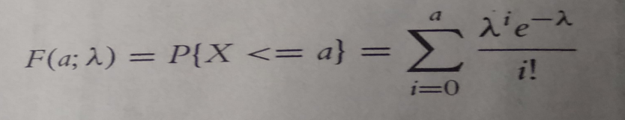

**Eg2:**

Assume that the test scores of a college entrance exam fits a normal distribution. Furthermore, the mean test score is 72 and the standard deviation is 15.2. What is the percentage of students scoring 84 or more in the exam?

Solution:

Normal Distribution:

μ= 72, σ= 15.2

p(x>=84)

1-p(x<84)



